Collaborative Institutional Training Initiative (CITI Program)

- Access https://about.citiprogram.org/ and select “Log In”.
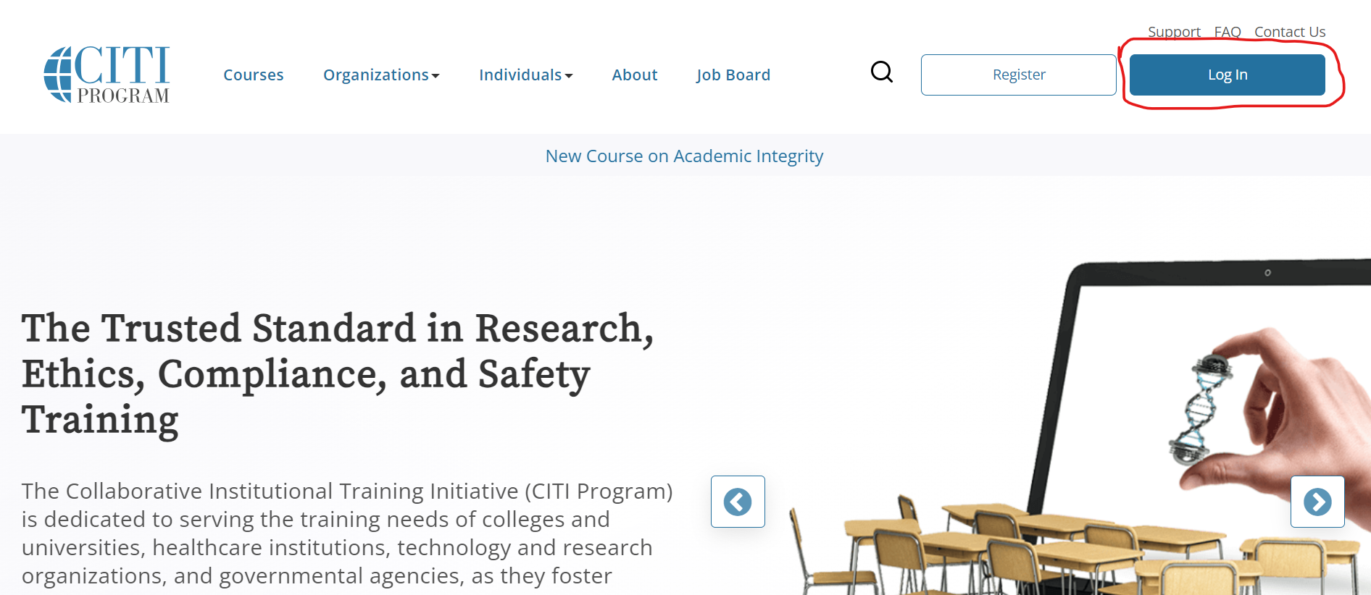

- Select “LOG IN THROUGH MY ORGANIZATION” and enter “National University of Singapore”, and then select “Continue To SSO Login/Instructions”.
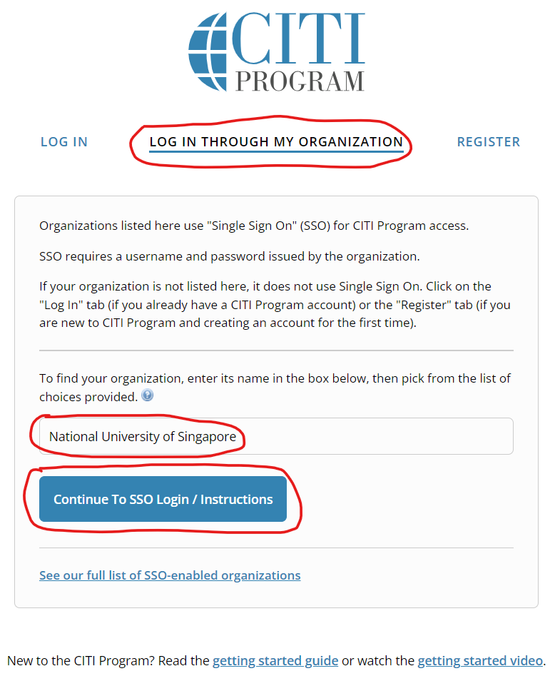

- Select or search for “Social & Behavioral Research - Basic/Refresher”
