Collaborative Institutional Training Initiative (CITI Program)

- Access https://about.citiprogram.org/ and select “Log In”.
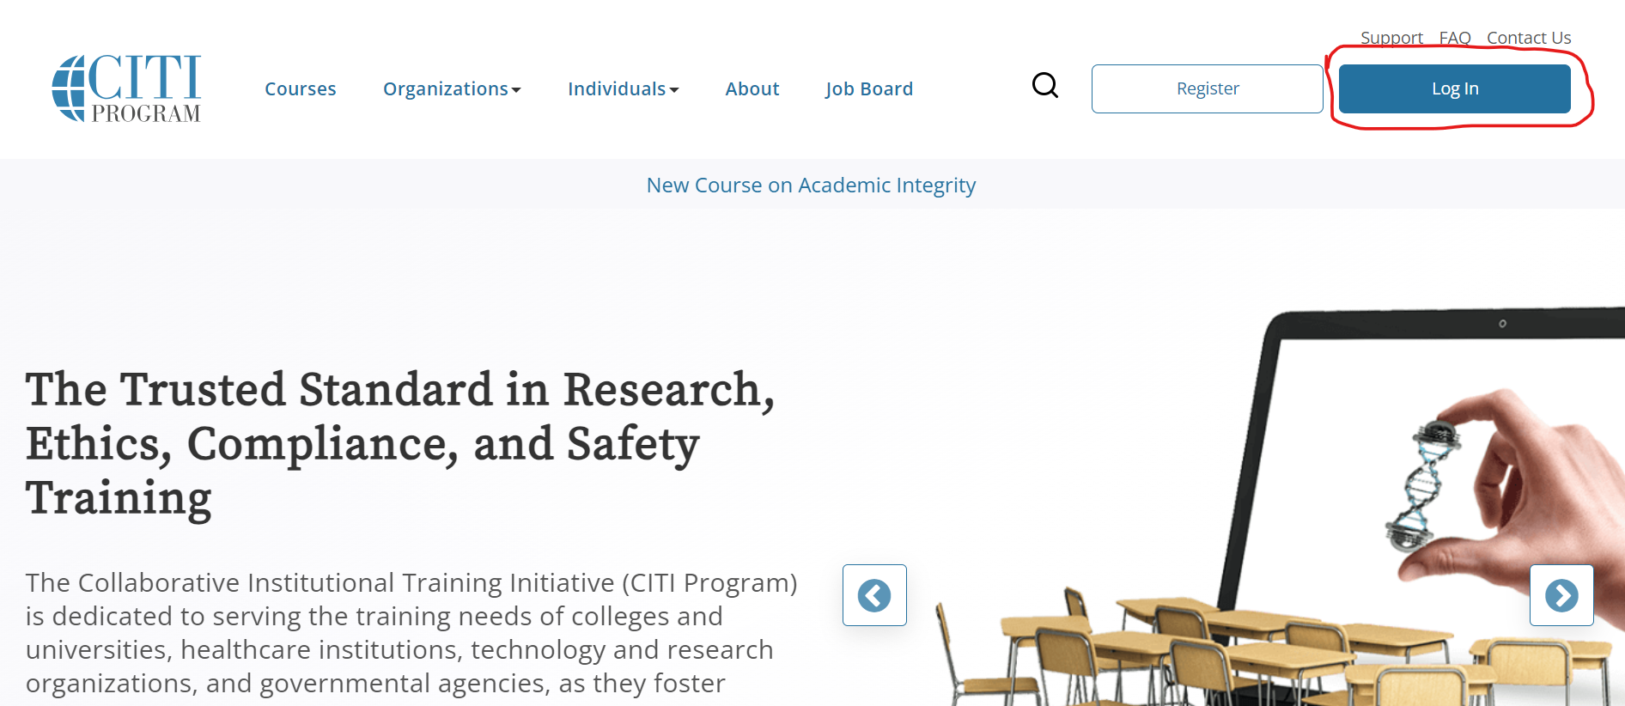

- Select “LOG IN THROUGH MY ORGANIZATION” and enter “National University of Singapore”, and then select “Continue To SSO Login/Instructions”.
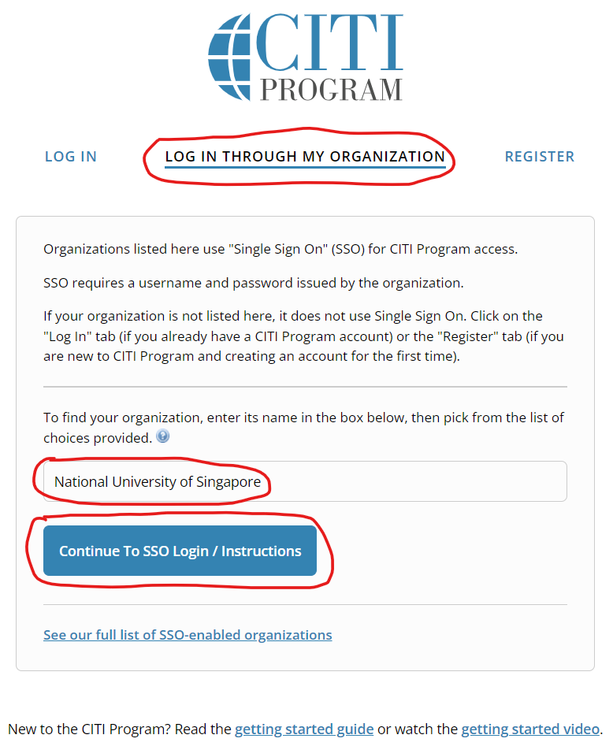

- Select or search for the “Social & Behavioral Research - Basic/Refresher” course.
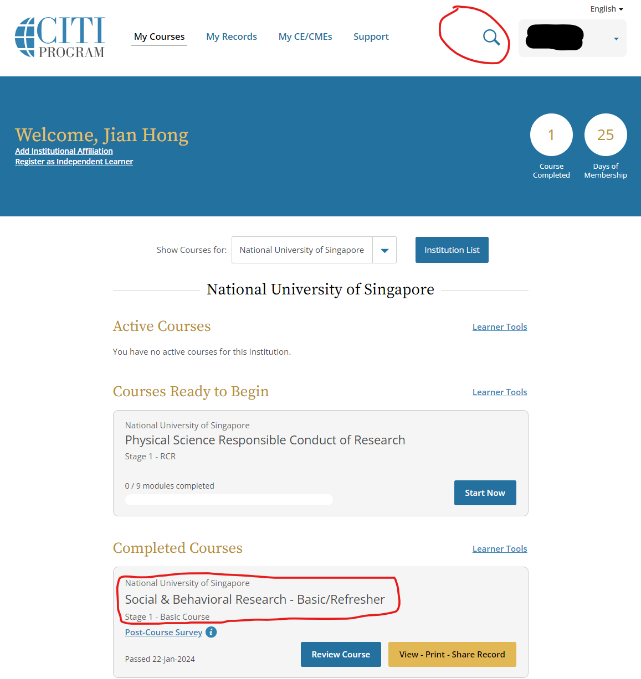

If the “Social & Behavioral Research - Basic/Refresher” course does not appear in your course list, please go to Steps 4) and 5).

- Scroll down to the bottom of the page and select “Add a course”.

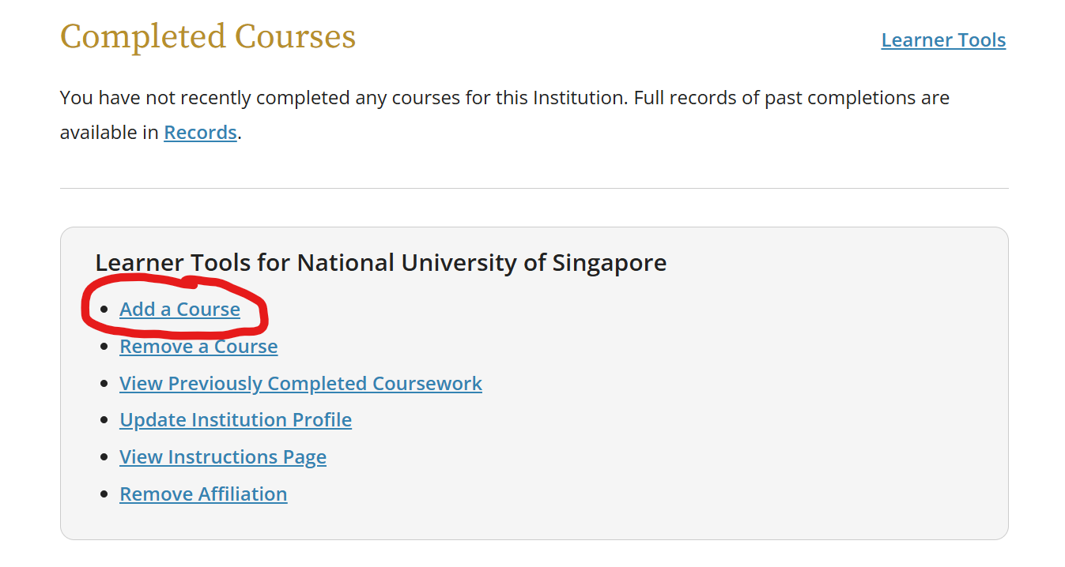

- Complete the following Questions 1 and 2 in the “Select Curriculum” page; ignore Question 3.

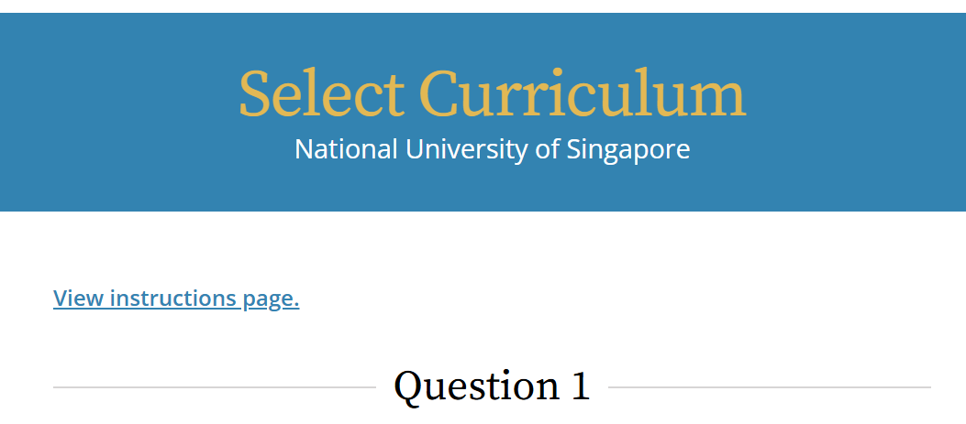
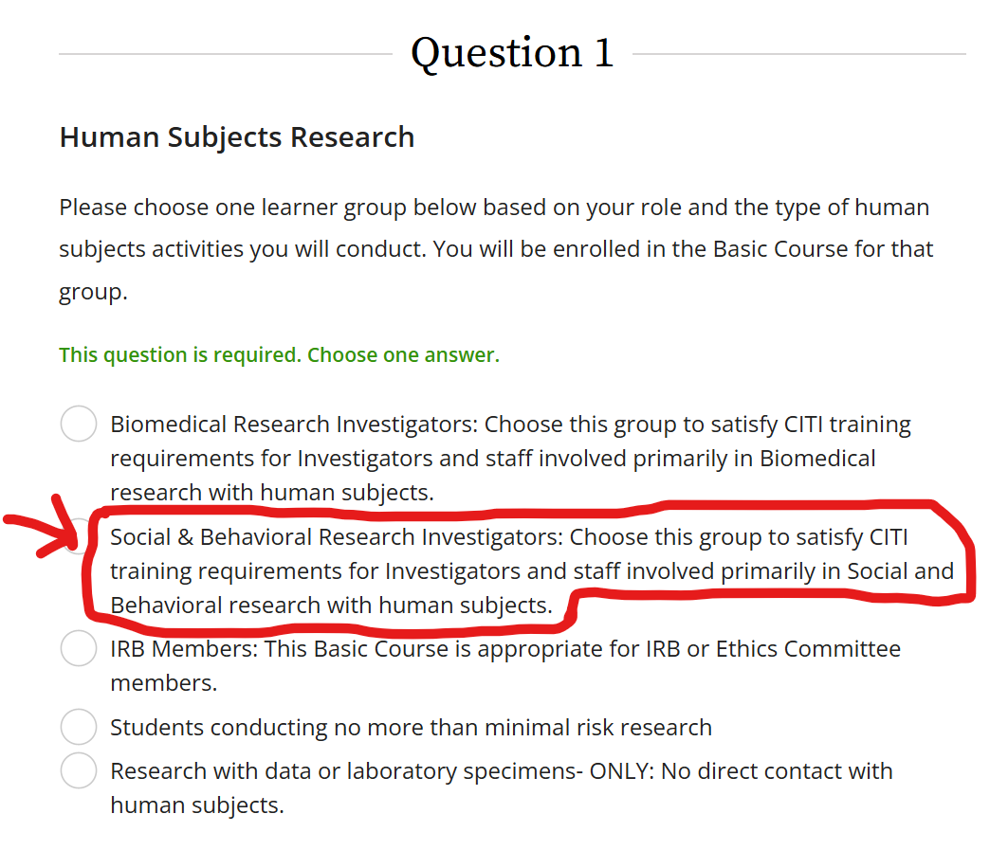

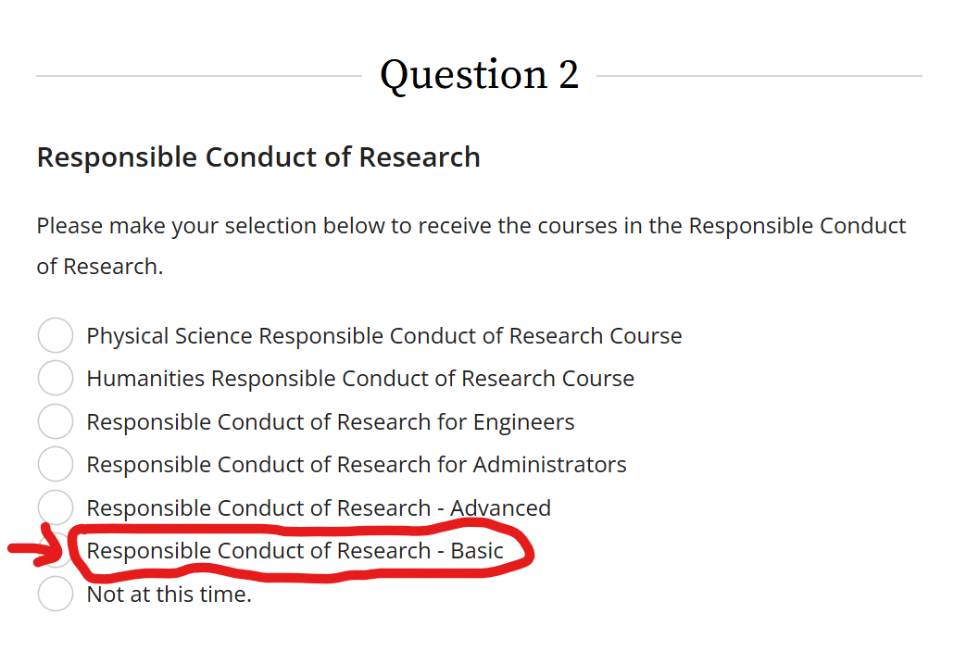
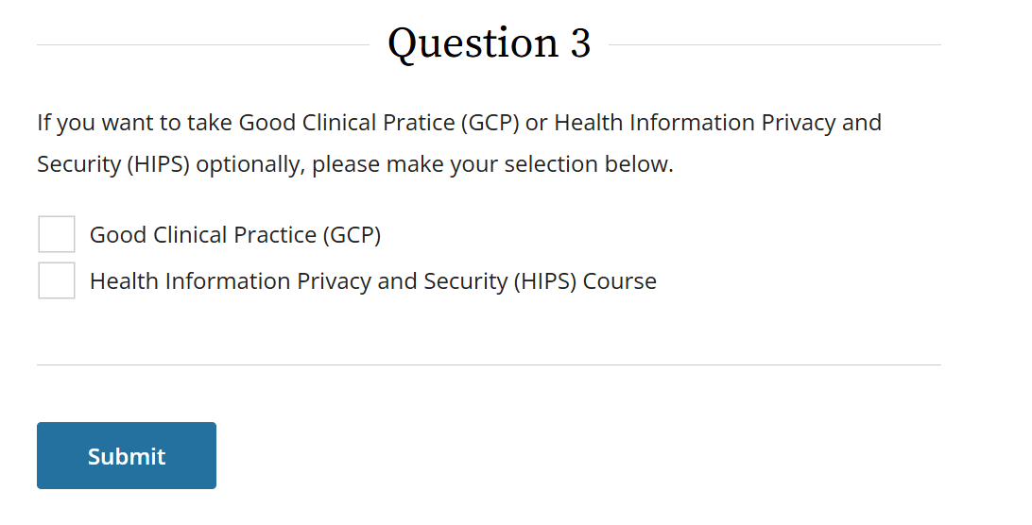

After completing and submitting your curriculum options, you should be able to find the “Social & Behavioral Research - Basic/Refresher” course in your course list.

Please contact the CDE Ethics Review Committee (CDE ERC) at cdebox5@nus.edu.sg if you have any questions or difficulties in doing so.

